APC-11 Student Visualization Competition Submittal Form

Please complete the forms below and submit them in both WORD and PDF formats to cfd-ws@chofu.jaxa.jp.
Submission Guidelines:
- Submission requirements: Minimum of one and maximum of three images. Please note that each image will be evaluated as a separate entry, regardless of whether they are submitted together.
- Format: Images should be in PNG format (300 dpi).
- Layout: Please do not alter the table dimensions. Before submitting, ensure you delete the sample entry provided in the form.
- Language: English is preferred, though Japanese is also accepted.
- Large Files: If your files exceed attachment limits, contact us at the email above for alternative submission methods.
For details on evaluation criteria, please refer to https://cfdws.chofu.jaxa.jp/apc/apc11/case1.html and accompany document “APC-11_Student_Visualization_Competition_v2.docx”.
Participant information
Full name
University, department
Email address

Image 1
Title of visualization
Short caption
(max 50 words)
Visualization context and purpose
What is being visualized?

Numerical solver and post-processing software details

What phenomenon does this visualization help explain or highlight?

Originality and innovation
What makes this visualization original or distinctive?

Did you develop any custom tools, scripts or processes for this image?

Image 2
Title of visualization
Short caption
(max 50 words)
Visualization context and purpose
What is being visualized?

Numerical solver and post-processing software details

What phenomenon does this visualization help explain or highlight?

Originality and innovation
What makes this visualization original or distinctive?

Did you develop any custom tools, scripts or processes for this image?

Image 3
Title of visualization
Short caption
(max 50 words)
Visualization context and purpose
What is being visualized?

Numerical solver and post-processing software details

What phenomenon does this visualization help explain or highlight?

Originality and innovation
What makes this visualization original or distinctive?

Did you develop any custom tools, scripts or processes for this image?

[SAMPLE ENTRY – delete this prior to submission]

APC-11 Student Visualization Competition Submittal Form

Please complete the forms below and submit them to cfd-ws@chofu.jaxa.jp.
Submission Guidelines:
- Submission requirements: Minimum of one and maximum of three images. Please note that each image will be evaluated as a separate entry, regardless of whether they are submitted together.
- Format: Images should be in PNG format (300 dpi).
- Layout: Please do not alter the table dimensions. Before submitting, ensure you delete the sample entry provided in the form.
- Language: English is preferred, though Japanese is also accepted.
- Large Files: If your files exceed attachment limits, contact us at the email above for alternative submission methods.
For details on evaluation criteria, please refer to https://cfdws.chofu.jaxa.jp/apc/apc11/case1.html and accompany document “APC-11_Student_Visualization_Competition_v2.docx”.
Participant information
Full name | Sarah Von Mach
University, department | Stratos Technical University, Department of Propulsion Systems
Email address | s.v.mach@stratos-tech.edu

Image 1
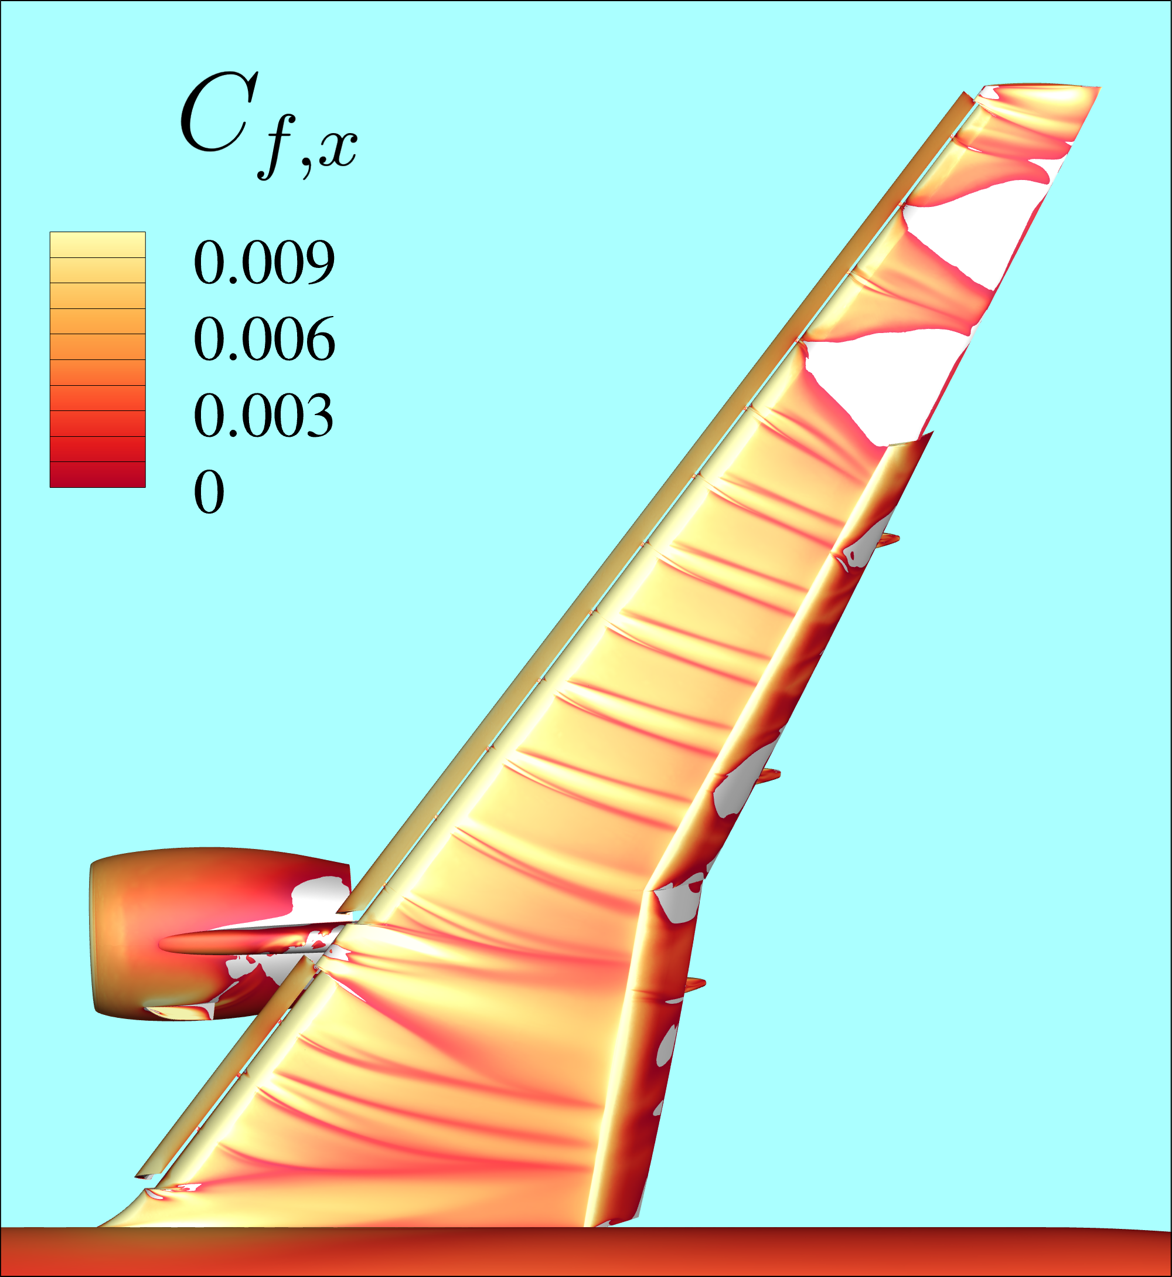
Title of visualization | Topological Mapping of Boundary Layer Separation on a Full-Scale Airframe
Short caption  (max 50 words) | This visualization depicts the streamwise skin friction distribution over the NASA CRM-HL full-aircraft configuration at high-alpha flight. By mapping the transition from attached flow to separation (indicated by white patches), the image identifies the onset of aerodynamic stall, providing critical data for wing-root and control-surface design optimization.
Visualization context and purpose
What is being visualized? | The image displays contours of the streamwise component of skin friction ($C_{f,x}$) on the upper surface of a complete aircraft geometry. The colormap is specifically calibrated to highlight regions where $C_{f,x}$ approaches or drops below zero, acting as a diagnostic tool for identifying flow reversal and boundary layer detachment.
Numerical solver and post-processing software details | An unstructured, cell-centered Finite Volume Compressible Solver named MYCFDCODE was used to solve the steady-state Reynolds-Averaged Navier-Stokes (RANS). Turbulence Model was the One-equation Spalart-Allmaras (SA-92) model. For data post-processing, Tecplot 360 was utilized for surface data extraction and high-fidelity rendering.
What phenomenon does this visualization help explain or highlight? | The visualization highlights the stall progression phenomenon. By identifying exactly where flow separation initiates—such as at the wing outboard region or flaps—engineers can predict how the aircraft will behave at its performance limits. It bridges the gap between raw numerical data and the physical understanding of aerodynamic loss.
Originality and innovation
What makes this visualization original or distinctive? | Unlike standard pressure plots, this visualization focuses on the topological "fingerprint" of the boundary layer. The specific use of a warm-toned colormap against a sky-blue backdrop creates a high-contrast "thermal signature" effect, making the subtle transition to separation immediately intuitive for the viewer while maintaining scientific rigor.
Did you develop any custom tools, scripts or processes for this image? | A custom Python-based Tecplot Macro was developed to automatically compute the streamwise projection of the skin friction vector relative to the local wing sweep. Additionally, a specialized gradient-smoothing script was used to filter high-frequency numerical noise from the unstructured grid, ensuring that the separation lines represent physical flow features rather than mesh artifacts.

